INTEGRATIVE COURSE IN PSYCHOLOGY (ICOPSYCH)

ANALYSIS ON THE RESULT OF POST-TEST EXAMINATION IN INDUSTRIAL PSYCHOLOGY
MARCH 15, 2025

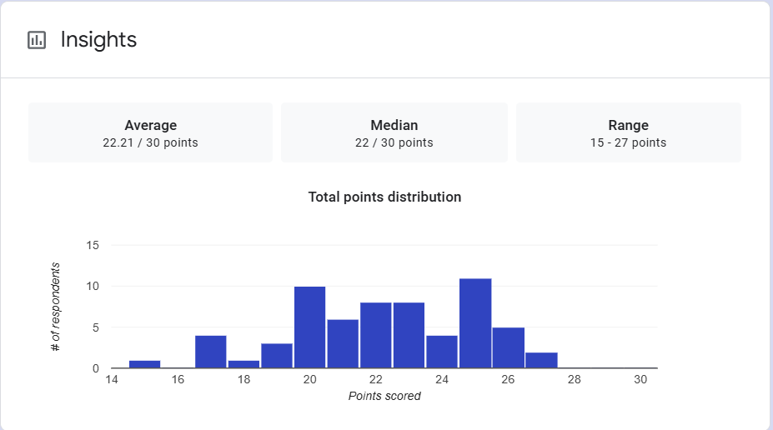

1. Mean Score: The average score is 22.21 out of 30. This indicates that, on average, students performed relatively well on the exam, with most scores concentrated around this value.

2. Median Score: The median score is 22 out of 30. The median represents the middle point, meaning that half of the students scored below 22 and half scored above 22. This suggests that the distribution of scores is fairly balanced around the central value.

3. Range: The range of scores is from 15 to 27 points. This shows that the exam results vary between a minimum of 15 points and a maximum of 27 points, indicating a spread of scores, but not a very wide one. The range suggests that while there were lower scores, there were also scores closer to the maximum, pointing to some variability in performance.

Interpretation Summary:

-The scores appear to be clustered around the average (22.21) and median (22), suggesting a fairly normal or symmetric distribution of scores.

-Since the median and mean are close in value, it likely implies there are no significant outliers or extreme scores that would skew the results.

-The range of 15 to 27 indicates some degree of variability in performance, but not an excessively large spread, suggesting that while there were some lower and higher scores, most students performed relatively similarly within a manageable score range.
-In conclusion, the overall performance on the exam seems fairly balanced with most students scoring around the middle of the scale.

RATIONALIZATION:

DIFFICULT QUESTIONS:

